**Hands on 1**

**Spring Data JPA - Quick Example**   
  
**Software Pre-requisites**

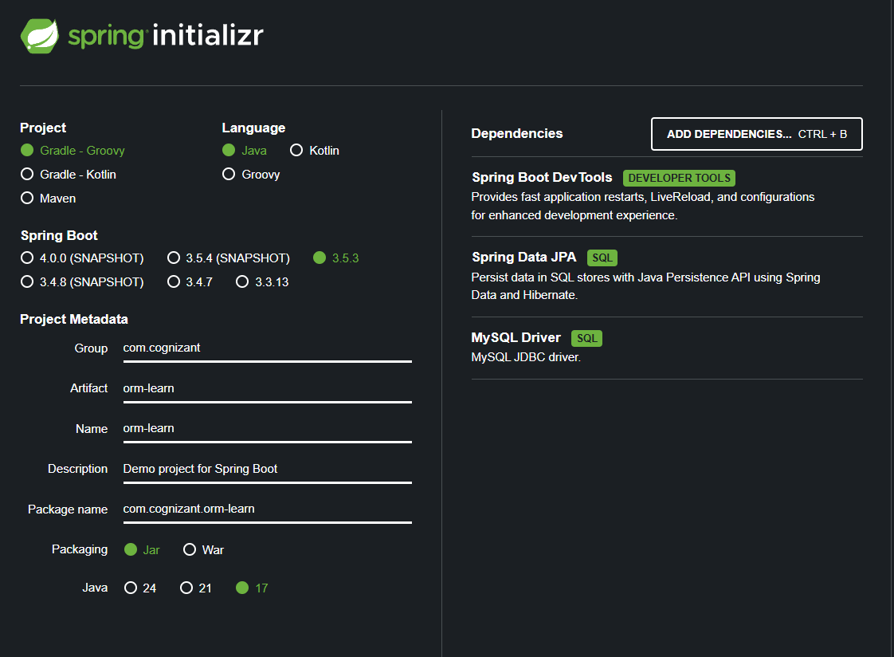

mysql -u root -p

**schema**

create schema ormlearn;

use ormlearn;

create table country(co_code varchar(2) primary key, co_name varchar(50));

insert into country values ('IN', 'India'), ('US', 'United States of America');

**application.properties**

logging.level.org.springframework=info  
logging.level.com.cognizant=debug  
logging.level.org.hibernate.SQL=trace  
logging.level.org.hibernate.type.descriptor.sql=trace  
logging.pattern.console=%d{dd-MM-yy} %d{HH:mm:ss.SSS} %-20.20thread %5p %-25.25logger{25} %25M %4L %m%n  
  
spring.datasource.driver-class-name=com.mysql.cj.jdbc.Driver  
spring.datasource.url=jdbc:mysql://localhost:3306/ormlearn  
spring.datasource.username=root  
spring.datasource.password=root  
  
  
spring.jpa.hibernate.ddl-auto=validate  
spring.jpa.properties.hibernate.dialect=org.hibernate.dialect.MySQL5Dialect

Country.java

package com.cognizant.ormlearn.model;  
  
import javax.persistence.*;  
  
@Entity  
@Table(name="country")  
public class Country {  
  
 @Id  
 @Column(name="co_code")  
 private String code;  
  
 @Column(name="co_name")  
 private String name;  
  
 // Getters & Setters  
 public String getCode() { return code; }  
 public void setCode(String code) { this.code = code; }  
 public String getName() { return name; }  
 public void setName(String name) { this.name = name; }  
  
 @Override  
 public String toString() {  
 return "Country [code=" + code + ", name=" + name + "]";  
 }  
}

CountryRepository.java

package com.cognizant.ormlearn.repository;  
  
import org.springframework.data.jpa.repository.JpaRepository;  
import org.springframework.stereotype.Repository;  
import com.cognizant.ormlearn.model.Country;  
  
@Repository  
public interface CountryRepository extends JpaRepository<Country, String> {  
}

CountryService.java

package com.cognizant.ormlearn.service;  
  
import java.util.List;  
import javax.transaction.Transactional;  
  
import org.springframework.beans.factory.annotation.Autowired;  
import org.springframework.stereotype.Service;  
  
import com.cognizant.ormlearn.model.Country;  
import com.cognizant.ormlearn.repository.CountryRepository;  
  
@Service  
public class CountryService {  
  
 @Autowired  
 private CountryRepository countryRepository;  
  
 @Transactional  
 public List<Country> getAllCountries() {  
 return countryRepository.findAll();  
 }  
}

OrmLearnApplication.java

package com.cognizant.ormlearn;  
  
import java.util.List;  
import org.slf4j.Logger;  
import org.slf4j.LoggerFactory;  
import org.springframework.boot.SpringApplication;  
import org.springframework.boot.autoconfigure.SpringBootApplication;  
import org.springframework.context.ApplicationContext;  
  
import com.cognizant.ormlearn.model.Country;  
import com.cognizant.ormlearn.service.CountryService;  
  
@SpringBootApplication  
public class OrmLearnApplication {  
  
 private static final Logger *LOGGER* = LoggerFactory.*getLogger*(OrmLearnApplication.class);  
 private static CountryService *countryService*;  
  
 public static void main(String[] args) {  
 ApplicationContext context = SpringApplication.*run*(OrmLearnApplication.class, args);  
 *countryService* = context.getBean(CountryService.class);  
 *LOGGER*.info("Inside main");  
  
 *testGetAllCountries*();  
 }  
  
 private static void testGetAllCountries() {  
 *LOGGER*.info("Start");  
 List<Country> countries = *countryService*.getAllCountries();  
 *LOGGER*.debug("countries={}", countries);  
 *LOGGER*.info("End");  
 }  
}

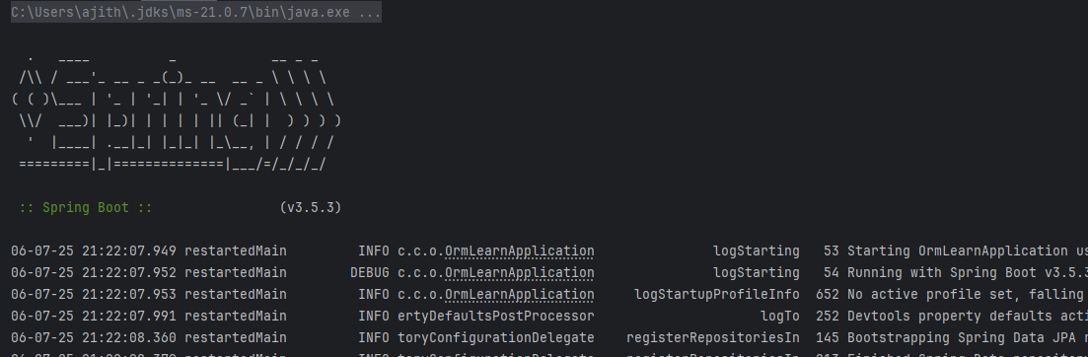

**Hands on 4**

**Difference between JPA, Hibernate and Spring Data JPA**

CREATE TABLE employee (

id INT PRIMARY KEY AUTO_INCREMENT,

name VARCHAR(50),

department VARCHAR(50),

salary DOUBLE

);

INSERT INTO employee (name, department, salary)

VALUES

('John Doe', 'Engineering', 75000),

('Jane Smith', 'HR', 60000);

**EmployeeRepository.java**

import org.springframework.data.jpa.repository.JpaRepository;  
import org.springframework.stereotype.Repository;  
import com.example.model.Employee;  
  
@Repository  
public interface EmployeeRepository extends JpaRepository<Employee, Integer> {  
}

**EmployeeService.java**

package com.cognizant.ormlearn.service;  
  
import java.util.List;  
  
import javax.transaction.Transactional;  
  
import org.springframework.beans.factory.annotation.Autowired;  
import org.springframework.stereotype.Service;  
  
import com.cognizant.ormlearn.model.Employee;  
import com.cognizant.ormlearn.repository.EmployeeRepository;  
  
@Service  
public class EmployeeService {  
  
 @Autowired  
 private EmployeeRepository employeeRepository;  
  
 @Transactional  
 public void addEmployee(Employee employee) {  
 employeeRepository.save(employee);  
 }  
  
 @Transactional  
 public List<Employee> getAllEmployees() {  
 return employeeRepository.findAll();  
 }  
  
 @Transactional  
 public Employee getEmployeeById(int id) {  
 return employeeRepository.findById(id).orElse(null);  
 }  
  
 @Transactional  
 public void deleteEmployee(int id) {  
 employeeRepository.deleteById(id);  
 }  
}

OrmLearnApplication.java

package com.cognizant.ormlearn;  
  
import java.util.List;  
  
import org.slf4j.Logger;  
import org.slf4j.LoggerFactory;  
import org.springframework.boot.SpringApplication;  
import org.springframework.boot.autoconfigure.SpringBootApplication;  
import org.springframework.context.ApplicationContext;  
  
import com.cognizant.ormlearn.model.Employee;  
import com.cognizant.ormlearn.service.EmployeeService;  
  
@SpringBootApplication  
public class OrmLearnApplication {  
  
 private static final Logger *LOGGER* = LoggerFactory.*getLogger*(OrmLearnApplication.class);  
 private static EmployeeService *employeeService*;  
  
 public static void main(String[] args) {  
 ApplicationContext context = SpringApplication.*run*(OrmLearnApplication.class, args);  
 *employeeService* = context.getBean(EmployeeService.class);  
  
 *testAddEmployee*();  
 *testGetAllEmployees*();  
 }  
  
 private static void testAddEmployee() {  
 *LOGGER*.info("Start testAddEmployee");  
 Employee e = new Employee();  
 e.setName("Alice Johnson");  
 e.setDepartment("Finance");  
 e.setSalary(88000);  
 *employeeService*.addEmployee(e);  
 *LOGGER*.info("Saved Employee: {}", e);  
 *LOGGER*.info("End testAddEmployee");  
 }  
  
 private static void testGetAllEmployees() {  
 *LOGGER*.info("Start testGetAllEmployees");  
 List<Employee> employees = *employeeService*.getAllEmployees();  
 for (Employee e : employees) {  
 *LOGGER*.info(e.toString());  
 }  
 *LOGGER*.info("End testGetAllEmployees");  
 }  
}

